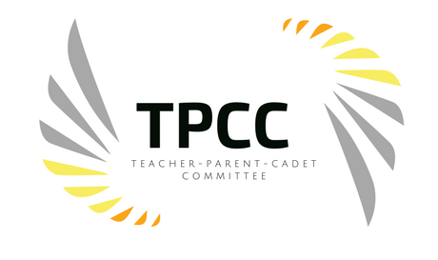
Behind every successful cadet there stands a supportive family. High school years are a pivotal time in a cadet’s life and family involvement can make a difference, not just for your own cadet but for all the cadets.
The Academy could not do their job without the support of the cadets and their families as well. It takes a village to educate, lead, and volunteer in the community. So, get involved.
Teachers, parents (guardians) and cadets are willing to donate their time to support Marion Military Academy events, school activities, fundraising, parades, school spirit and so much more. We work together in support of a positive atmosphere and experience for all cadets.
The committee meets once a month to discuss upcoming events, create fundraising opportunities and to coordinate volunteer opportunities for the Academy. Another crucial piece of the committee is reaching out to all parents of the Academy to ensure they have the resources they need to assist their cadet(s) with academic excellence.

TEACHER-PARENT-CADET PARTICIPATION FORM
Name
Cadet Name and Grade
Best Contact Phone Number
Text Capable?
Email
Address
City and Zip
Have you completed a Volunteer Form?
I am a ____Guardian ____ Teacher (Admin) ____ Cadet
There are many volunteer opportunities at Marion Military Academy but we want to know what interests you most. Below are a list of some of the potential needs that we have at the Academy, please check all those you may be interested in assisting with:
____ tutoring ____ clinic ____ substitute ____ field trips
____ after school activities ____ school dance ____ military ball
____ community service ____ mentoring ____ fundraising
Please list any other interested that may not be listed:

